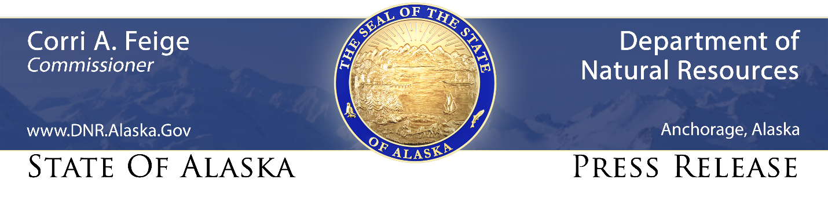
For Immediate Release: August 18, 2021

Allie Barker and Jed Workman are Alaska Farm Family of 2021
(Palmer, AK) – Alaska’s Farm Family of the Year for 2021 are Allie Barker and Jed Workman of Chickaloon, owners and operators of Chugach Farm, where they grow nutrient-dense food through sustainable and regenerative methods with a focus on living self-sufficiently.

“Chugach Farm is the perfect example of what growing the agriculture sector in Alaska looks like,” said Governor Mike Dunleavy. “I applaud the efforts of Allie Barker and Jed Workman in working to help Alaskans across the state achieve self-sufficiency with sustainable food for now and in the future.”

The lure of mountain climbing in Alaska drew Barker and Workman north separately 23 years ago when Barker, born in Ohio, and Workman, born in Connecticut, met during a 40-day mountaineering employment training expedition on the Nelchina and Matanuska glaciers. They eventually married and in 2002, driven by the desire to live off the land and grow their own food, purchased raw land out of pocket to build their off-grid homestead and farm from the ground up.

In 2010, the couple decided to share their nutritious food with others, and committed to farming, nutrition, making ferments, and putting up food full time. She is responsible for the farm operations, while he focuses on maintaining their off-grid systems, helps with building projects, mixes and ferments animal food, takes care of the animals, and is an avid cook.

Barker is drawn to the challenge and hard work of farming, and says it’s “the only thing that is harder than guiding on Denali.” The family’s focus is on producing nutrient-dense, single-origin, sustainable food by using regenerative agriculture, alternative energy, and no-till farming methods. The couple operate a program to donate food to hungry kids through the Kids Kupboard, and have hired people for intensive apprenticeships and many other positions.

“Allie and Jed embody the innovative, resilient spirit of Alaska Agriculture, even in the face of a global pandemic,” said Division of Agriculture director David W. Schade. “We are proud they were selected as Farm Family of the Year.”

The “Farm Family of the Year” award was established in 2000 by the Alaska Division of Agriculture and the Alaska State Fair with the intent to honor an Alaska farm family that best epitomizes the spirit of the industry that year, and to show appreciation for hard-working Alaskans committed to agriculture.

The Alaska Farm Family of the Year for 2020 was the Bates of Halibut Cove, Alaska. Previous winners include the St. Pierres of Ester, Olsons of Soldotna, and the McCollums and Pinklemans of Delta Junction.

CONTACT: Amanda Swanson, (907) 761-3869, amanda.swanson@alaska.gov

###

